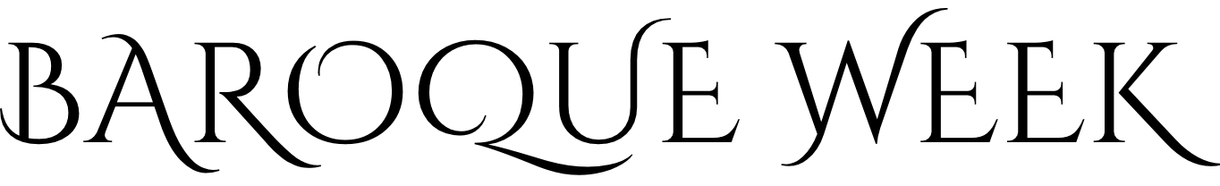
BURSARY APPLICATION FORM
Please send your completed form to admin@baroqueweek.uk or post it to: Course Administrator, Baroque Week, 118 Wise Lane, East Knoyle, Salisbury, Wilts SP3 6AB, United Kingdom. Please also complete the main application form for singers or instrumentalists as appropriate.

Name: Age group on the first day of the course:
Address: 18-22 30-49
23-29 50+
Telephone – Home:
Postcode: __________ Country: ____________________ Mobile:
E-mail address: ___________________________________
Corridor allocation for your bedroom/showers: male female
It is possible we may ask some bursary students to share a twin bedroom. Is there any reason why you would NOT be able to share with a student of a similar age and the same gender?

What instrument(s)/voice part would you like to play and/or sing at Baroque Week?

Please describe your musical experience and education, including your experience of baroque chamber music. Continue on a separate page if necessary.

What are your musical ambitions? Continue on a separate page if necessary.

How do you think your attendance at Baroque Week would benefit you or others?

How much are you applying for, and how will you meet the rest of the cost of attending Baroque Week? Note that we award bursaries for 50%, 75% or 100% of the course fee; if you would be unable to contribute at least 25% (£232 for 2026) please explain in the next question.

Please describe your financial situation and why you need a bursary in order to attend Baroque Week. Continue on a separate page if necessary.

Are you seeking funding from any other body or individual? Please indicate when you expect to have their decision.

(For our information only) How did you hear about Baroque Week?

I confirm that all the information in this application is correct. I understand that Baroque Week reserves the right to recover any award made on the basis of false information.

I will advise Baroque Week immediately if I have to withdraw my application, or if there are any significant changes in the information I have given on this form.

I give permission for Baroque Week to record the information in this form electronically and to contact me by phone, mail or e-mail with regard to this application.

Signed: Date:
(Electronic signature acceptable if sent from your own e-mail address)

